

**Title (Papers must be written in Times New Roman with fonts 14 p )**

**Author name1\*** [](https://orcid.org/) **[](mailto:aesam365@yahoo.com), Author name2** [](https://orcid.org/) **[](mailto:aesam365@yahoo.com) and Author name3** [](https://orcid.org/) **[](mailto:aesam365@yahoo.com) 12p**

1Department, College, University, City, Country.

2Department, College, University, City, Country.

3Department, College, University, City, Country.

*Corresponding Author. 11p

Received: Accepted: Published:

**doi.org/00.000000.000000**



**Abstract 12p**

Use this document as a template if you use Microsoft Word 2016 or later. Otherwise, use this document as an instruction set. Your paper's electronic file will be formatted further at IHJPAS. Paper titles should be in uppercase and lowercase letters, not all uppercase. Avoid writing long formulas with subscripts in the title; short formulas that identify the elements are acceptable (e.g., "Nd–Fe–B"). Do not write "(Invited)" in the title. Be sure to adhere to these limits; otherwise, you must edit your abstract accordingly. The abstract must be structured as the following subheading with word counts between 150-300.

**Background:**

**Objectives:**

**Materials and Methods:**

**Results:**

**Conclusion:**

**Keywords:** (4 - 6 words). It should be written in Times New Roman, single-spaced, with line spacing of 1.15 and 12p font size, and acronyms should be avoided.

- Each manuscript should have at least one objective from Sustainable Development Goals for Natural Science.

-To help you create keywords from an abstract, use MeSH on Demand (<https://meshb.nlm.nih.gov/MeSHonDemand>) as a tool that can automatically generate keywords.

**1. Introduction**

Provide a context or background for the study, the nature of the problem, and its significance. State the specific purpose, research objective, what is known, controversies, and research gap. Provide only directly pertinent references, and do not include data or conclusions from the reported work. Start with a global view, regional rather than local. Write in an ‘inverted triangle’ (in three paragraphs ideally), and end with the rationale/relevance of the study.

- References should be cited in the text by sequential numbers.

After a direct quote, the numbers usually appear after the name of the author. They may also appear at the end of the sentence:

Examples:

* Levitt (1) argues that …

If a source has multiple authors, name only the first author followed by ‘*et al*.’:

* Davies *et al.* (2) argue that …

It’s not always necessary to mention the author’s name in your text – but always include the reference number when you refer to a source:

* Another study (3) explores the concept of …
* This phenomenon is increasingly relevant to the discipline (4).
* if the sentence cites two references (1, 2).
* If sentence cites four references (1–4).
* cites non - sequential references (1–4, 7–9, 10).

**Note:**

- **Do not Exceed one page for the Introduction**.

**2. Materials and Methods**

Include details on materials and methods, where, when, how, who, why, etc., with the elaborate process so that the study can be ‘reproduced.’

- Describe the study population in detail, including controls.

- Describe the methods and procedures so other workers can reproduce the results. If the techniques are new or substantially modified, describe them and state their limitations. When reporting research on human beings, the authors must ensure that a medical ethics committee approves the work and that the subjects consent to participate. The Methods section should include only information available when the plan or protocol for the study was written; all information obtained during the study is in the Results section.

Selection and Description of Participants

- Describe your selection of the observational or experimental participants (Subjects or laboratory animals, including controls) clearly, including eligibility and exclusion criteria and a description of the source population.

**3. Results**

Present your results logically in the text, tables, and illustrations, first give the main or most important findings based on your study objective. Do not repeat all the data in the tables or illustrations. Emphasize or summarize only the most important observations. Extra or supplementary materials and technical details can be placed in an appendix where they will be accessible. Still, they will not interrupt the text flow, or they can be published solely in the electronic version of the journal.

When data are summarized, give number and percent in the format of xx (xx%), the absolute numbers from which the derivatives were calculated, and specify the statistical methods used to analyze them, for example, 5 (20%) without space between the number and bracket containing percentage (avoid using formats of 46% (460), 46% (460/1000) unless in exceptional cases to better explain the flow of text), no space between number and percentage (e.g., 20%), SD(45±1.12), p<0.05, p>0.05, p=0.05 (use no space before after symbol). .

**Table 1.** The number for different geometric cases (size 10)

|  |  |  |
| --- | --- | --- |
| **HD** | **VD = 0** | **VD = 1** |
| 3 | 0.198 | 0.083 |
| 5 | 0.184 | 0.1 |
| 7 | 0.176 | 0.2 |

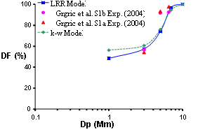

**Figure 1.** Comparison of the present numerical results with the experimental data for deposition fraction of microparticles in a flow rate of 60 lit/min. (size 10)

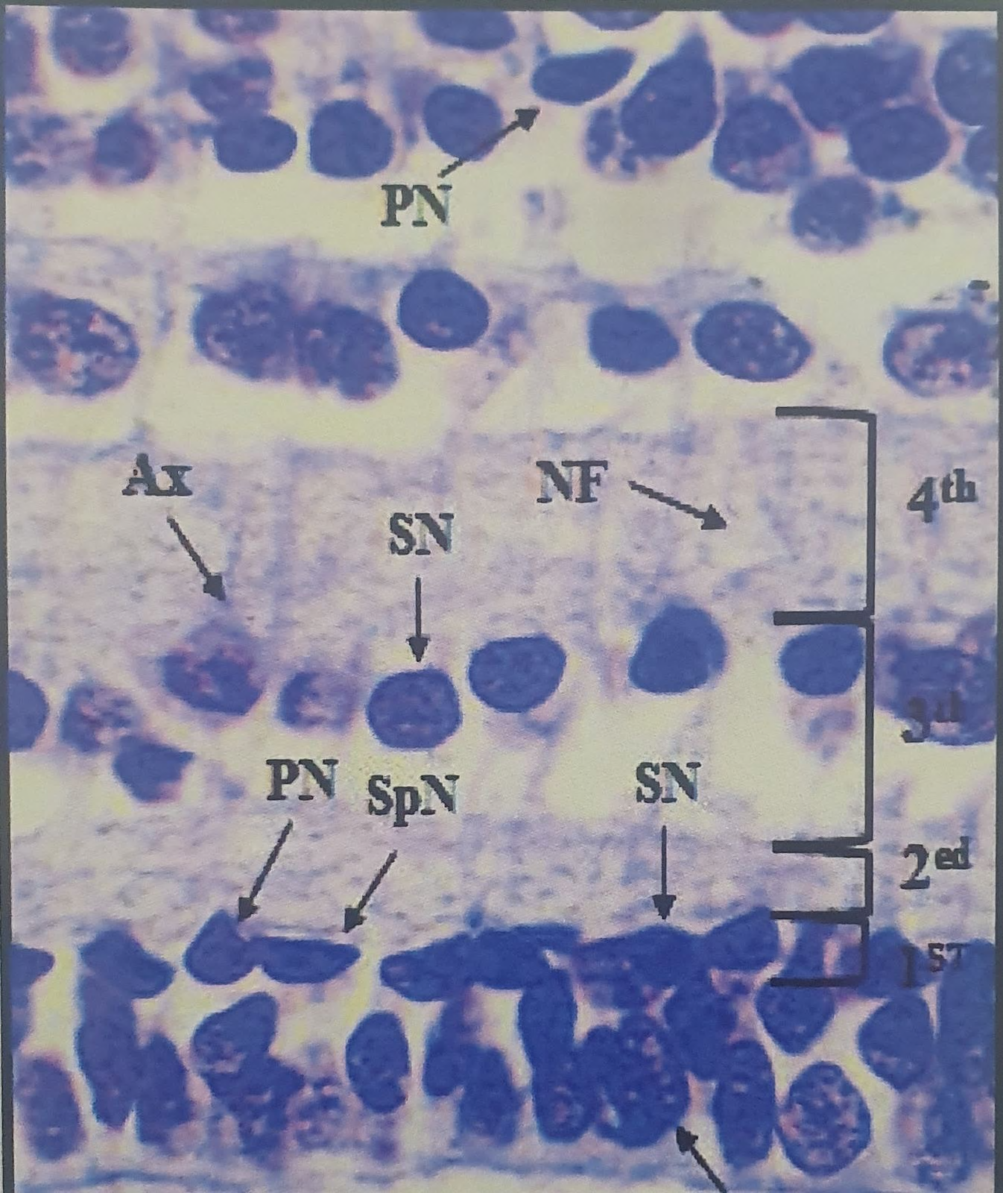

**Figure 2.** Type of section, Name of organ, Scientific name of animal or plant with all details of section, type of stain and magnification power 4x or another powers. (size 10)

Also, the Figures must be formed by (Microsoft Excel or MATLAB or any similar program), free of the color background, have no border or border legend, have no vertical or horizontal lines, and be of better quality for publishing. All Equations must be written by (equation editor utility), unique numbers, and references in the body, the same as Equation (1).

$G_{i}=\sqrt{-2\ln{U_{i}}}\text{ cos}(2πU_{j})$ (1)

- For footnotes use the symbol (*).

Please send all pictures in (JPEG, EPS, PS, TIFF) format with a resolution of more than 300 – 600 dpi and without borders, with the capital first letter of the axis titles, and write its unit. The text body must refer to Tables and Figures placed in the mentioned sequence, not at the end of the manuscript.

Also, each word in subsections must be capitalized, with font size in bold 12p. as:

**2.1. Subtitle**

**2.1.1. Sub-Subtitle**

**2.1.2. Sub-Subtitle**

**Note:**

- In the text body, must be not begin with abbreviations, number of Tables, or Figures in any paragraph of your manuscript.

- Table title should be brief, clear, and descriptive but sufficiently explain the data included. Captions for tables are placed above the table.

- For all types of figures, you must add a figure title presented and numbered in the same way as the table caption, except for the position of the figure caption placed below the figure.

**4. Discussion**

Emphasize and start a discussion with the crucial finding/s of your research and the conclusions that follow from them to support your study objective. Do not repeat data or other information given in the ‘Introduction or the Results section’ in detail. Begin by summarizing the main findings, then explore possible mechanisms or explanations limitations for these findings, compare and contrast with relevant literature with a logical explanation as to why your conclusions are similar or different, state the of the research based on your methodology and findings, and explore the implications for future research/practice.

**Note:**

- Results and discussion must be separated in biology and chemistry research, while they can be separated or merged in the others (Computer, Mathematics, and Physics).

- Don't refer to the Tables or Figures in the Discussion section.

**5. Conclusion**

It must be including the concluded results, in short and concise paragraph.

**Acknowledgment**

Acknowledgments are a place to recognize any contributions made to the paper that do not meet the criteria for authorship. This may include technical support, gifts received, or organizational assistance.

**Conflict of Interest**

All authors should include a statement disclosing any financial or other substantive conflicts of interest that may be construed to influence the results or interpretation of their manuscript.

- If there is no conflict of interest, the authors should state that:

“The authors declare that they have no conflicts of interest.”

**Funding**

Financial support in preparation for the publication must be included in the funding section if any**.**

**Ethical Clearance**

Ethical approval obtained should be mentioned (number and date). Indicate whether the procedures followed were according to ethical standards .When reporting experimental results, indicate whether the institution’s or a national research council’s guidelines or any national laws were followed.

**References**

**-** References must be styled in Vancouver format.

-Mendeley reference manager must be used to organized the reference list with DOI.

- References are written only in the English language

- References font size must be 11pt.

- References must be up-to-date of which (70%) from the last seven years.

- Involvement of at least 20% of the manuscript’s references from journals, books, etc.. indexed within the Scopus database.

- Find articles published in our journal, related to the topic of your research and cite at least two of them.

**Examples:**

The information you provide differs according to the type of source you’re citing, since different details are relevant in different cases. Formats and examples for the most commonly cited source types are given below.

◼ [**Book**](https://www.scribbr.co.uk/referencing/vancouver-style/)

|  |  |
| --- | --- |
| **Format** | x. Author(s). Title. Edition. Place of publication: Publisher; Year. |
| **Example** | 1. Wilkinson IB, Raine T, Wiles K, Goodhart A, Hall C, O’Neill H. Oxford handbook of clinical medicine. 10th ed. Oxford: Oxford University Press; 2017. |
| **Notes** | Editions are given (in abbreviated form) only when referring to an edition other than the first. |

◼ [**Book chapter**](https://www.scribbr.co.uk/referencing/vancouver-style/)

|  |  |
| --- | --- |
| **Format** | x. Author(s). Title of chapter. In: Editor(s), editors. Title of book. Place of publication: Publisher; Year. Page range. |
| **Example** | 2. Darden L. Mechanisms and models. In: Hull DL, Ruse M, editors. The Cambridge companion to the philosophy of biology. Cambridge: Cambridge University Press; 2008. p. 139–159. |
| **Notes** | - The first name given is that of the author, while the editor’s name appears later, followed by ‘editors.  - The page range indicates the location of the chapter in the book, and is preceded by ‘p.’ |

◼ [**Journal article**](https://www.scribbr.co.uk/referencing/vancouver-style/)

|  |  |
| --- | --- |
| **Format** | x. Author(s). Article title. Journal Name (abbreviated). Year; Volume(Issue):page range. DOI |
| **Example** | Bute M. A backstage sociologist: Autoethnography and a populist vision. Am Soc. 2016; 47(4):499–515. <https://doi.org/10.1007/s12108-016-9307-z> |
| **Notes** | - Use the abbreviated form of the journal’s name, which should be provided in the citation information for the article.  - Include a DOI when citing an online journal. End with the page range if you cite a print journal.  - Note the lack of spacing between the volume, issue and page range.  - The names of months are abbreviated.  - Page numbers for journals are not preceded by ‘p.’. |

◼ [**Website**](https://www.scribbr.co.uk/referencing/vancouver-style/)

|  |  |
| --- | --- |
| **Format** | x. Author(s). Title [Internet]. Year [cited Date]. URL |
| **Example** | Cancer Research UK. Current research into breast cancer [Internet]. 2020 [cited 2020 Feb 14]. Available from: https://www.cancerresearchuk.org/our-research/our-research-by-cancer-type/our-research-into-breast-cancer/current-breast-cancer-research |
| **Notes** | - Web pages often won’t have a clearly identified author; in this case, you can usually name a corporate author.  - The date used is the year when the website was last updated. The date in square brackets is when you accessed the site. |

**◼ Thesis and dissertations**

Thesis including Ph.D. dissertations, Master's theses, or Bachelor theses follow the basic format outlined below.

- Zhou Y. Resource Management in Wireless Networks: Queue Management and Scheduling in Mesh Networks and Multi-Access Control in Internetworking Systems. Doctoral dissertation, George Washington University: Washington, DC, 2010.