**Title ( must be written in Times New Roman with fonts 14 p )**

**Author name1\***[](https://orcid.org/0009-0002-8259-4959)**[](mailto:aya.hussein.g@gmail.com), Author name2**[](https://orcid.org/0000-0001-8534-0749)**[](mailto:dulrahman.h.majeed@almamonuc.edu.iq), and Author name3**[](https://orcid.org/0009-0002-9351-4176)**[](mailto:shrooq.smeein@hct.edu.om) 12pt**

1Department, College, University, City, Country.

2Department, College, University, City, Country.

3Department, College, University, City, Country.

*Corresponding Author. 11pt

**Beginning with Volume 39, the journal will transition to this updated template.**

Received: dd/mm/yyyy. Revised: dd/mm/yyyy. Accepted: dd/mm/yyyy. Published: dd/mm/yyyy.

doi.org/00.000000.000000

**Abstract 10pt**

Use Microsoft Word 2016 or later when you are writing your manuscript. The manuscript must be formatted for the IHJPAS journal. Each word in the manuscript titles should start with a capital letter, avoiding long formats that include underscores. Short formulas identifying the elements are acceptable (e.g., "Nd–Fe–B"). The abstract must be structured as **background, objectives, materials and methods, results, conclusion**, and should contain between 150 and 300 words.

**Keywords:** (4 - 6 words). It should be written in Times New Roman, single-spaced, with line spacing of 1 and 10p font size, and acronyms should be avoided. To help you create keywords from an abstract, use MeSH on Demand (<https://meshb.nlm.nih.gov/MeSHonDemand>) as a tool that can automatically generate keywords.

1. **Introduction (**12pt)

Provide a background for the study and the nature of the problem. State the specific purpose, the research objective, the state of knowledge, and the research gap. Do not include introductory tables or figures. Include only directly relevant references. The Introduction must not exceed 1000 words. References should be cited in the text with consecutive numbers (superscript). After a direct quotation, the numbers normally appear after the author's name. They can also appear at the end of the sentence: (*e.i.* Levitt1 argues that …)

If a reference has multiple authors, name only the first author followed by ‘*et al*.’

(*e.i.* Davies *et al.*2 argue that …)

* If the sentence cites two references1, 2
* If the sentence cites four references1– 4
* The cites of non-sequential references1– 4, 7– 9, 11

**2. Materials and Methods (**12pt)

Include details on materials and methods by describing the processes and procedures, if the methods are new or substantially.

If there is a need to add any subsection within the “Materials and Methods,” “Results,” or “Discussion” sections, it must be written as follows:

2.1. Subsections

Should start at the beginning of the line without any indentation.

2.1.1 Sub-Subsections

2.1.2 Sub-Subsections

**3. Results (**12pt)

Present your results logically in the text, tables, and figures. First, give the main or most important findings based on your study objective. Do not repeat all the data in the tables or figures. Emphasize or summarize only the most important observations.

**Tables: The caption font size is 10pt**

The title of the table should be written at the top, with the text aligned within the cells. Use the symbol (*) for footnotes.

**Table 1.** The number for different geometric cases (size 10p)

|  |  |  |
| --- | --- | --- |
| HD | VD = 0 | VD = 1 |
| 3 | 0.198 | 0.083 |
| 5 | 0.184 | 0.1 |
| 7 | 0.176 | 0.2 |

**Figures**

The caption of the figure should be below it. It must be in TIFF format with a resolution of at least 600 dpi to ensure clarity and high quality. Figures must not contain any logos or watermarks.

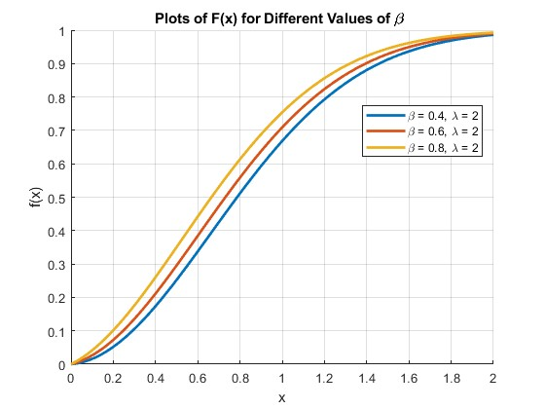

**Figure 1.** The shape of cdf for new Shanker Weibull distribution with different values of $β$ (size 10p)

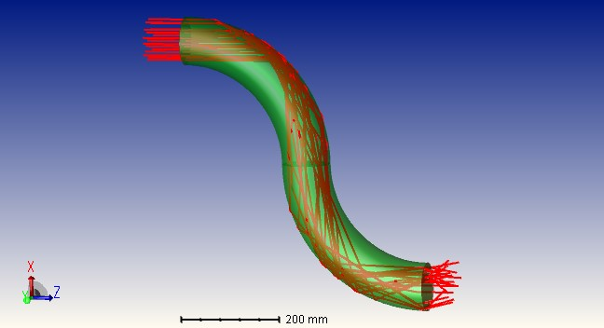

**Figure 2.**  S-shape circular cross-section torus waveguide model (size 10p)

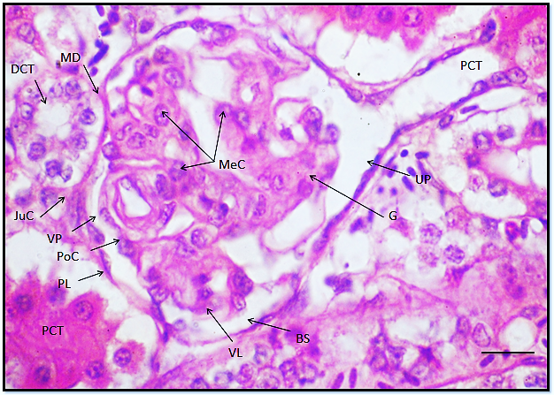

**Figure** 3**.** Type of section, Name of organ, Scientific name of animal or plant with all details of section, type of stain and magnification power 4x or another power, scale bar**.** (size 10)

**Equations**

To ensure accuracy and professional formatting, all equations must be written using the equation editor in Microsoft Word.

$G_{i}=\sqrt{-2\ln{U_{i}}}\text{ cos}(2πU_{j})$ (1)

**Note:** When referring to a figure, table, andequation within the text, its number must be clearly stated and in bold, such as "according to **Figure 1, Table 1**, and **Equation (1)**, respectively.

**4. Discussion (**12pt)

In this section, highlight the key findings of your research, and initiate a discussion to support your study objective. Do not repeat the data or other information from the ‘Introduction or Results' section in detail. Begin with a summary of the main findings, then explore possible mechanisms or explanatory limitations for these findings. Do not refer to the tables or figures in the Discussion section.

**Note:** The results and Discussion sections must be separated in the Biology, Chemistry, and Physics manuscripts, while they can be merged in the Computer and Mathematics manuscripts.

**5. Conclusion (**12pt)

It must include the concluded results in a concise paragraph.

**Acknowledgment (**12pt)

Acknowledgments are a place to recognize any contributions made to the manuscript that do not meet the criteria for authorship. This may include technical support or organizational assistance.

**Conflict of Interest (**12pt)

All authors should include a statement disclosing any financial or other substantive conflicts of interest that may be construed to influence the results or interpretation of their manuscript.

If there is no conflict of interest, the authors should state that: “The authors declare that they have no conflicts of interest.”

**Funding (**12pt)

The funding section must include any financial support for the submitted work.

**Ethical Clearance (**12pt)

Ethical approval obtained should be mentioned (number and date). Indicate whether the procedures followed were according to ethical standard. When reporting experimental results, indicate whether the institution’s or a national research council’s guidelines or national laws were followed.

**References**

**The references must be in Vancouver format.**

Mendeley reference manager is preferred to be used to organize the reference list with DOI. The font size of the references must be 11pt. The references must be at least 30 references and (70%) must be from the last seven years. At least 20% of the manuscript’s references must be from journals, books, etc. that are indexed in the Scopus database.

**Examples:**

The information you provide differs according to the type of source you’re citing since different details are relevant in various cases. Formats and examples for the most commonly cited source types are given below.

◼ [**Book**](https://www.scribbr.co.uk/referencing/vancouver-style/)

|  |  |
| --- | --- |
| **Format** | Author(s). Title. Edition. Place of publication: Publisher; Year. |
| For Single Author | Hoppert M. Microscopic techniques in biotechnology. Weinheim (Germany): Wiley-VCH; 2003. |
| E-book: Two or More Authors or Editors | Murray PR, Rosenthal KS, Kobayashi GS, Pfaller MA. Medical microbiology. 4th ed. St. Louis: Mosby; 2002. |
| Book: Two or More Authors or Editors | Gilstrap LC, Cunningham FG, Van Dorsten JP, editors. Operative obstetrics. 2nd ed. New York: McGraw-Hill; 2002. |

◼ [**Book chapter**](https://www.scribbr.co.uk/referencing/vancouver-style/)

|  |  |
| --- | --- |
| **Format** | Author(s). Title of chapter. In: Editor(s), editors. Title of book. Place of publication: Publisher; Year. Page range. |
| Chapter or Article in Edited E-book | Jones NA, Gagnon CM. The neurophysiology of empathy. In: Farrow TFD, Woodruff PWR, editors. Empathy in mental illness [e-book]. Cambridge (UK): Cambridge University Press; 2007: 217-38. https://ebookcentral-proquest-com.libproxy.murdoch.edu.au/lib/murdoch/detail.action?docID=293348. |
| Chapter or Article in Edited Print Book | Meltzer PS, Kallioniemi A, Trent JM. Chromosome alterations in human solid tumors. In: Vogelstein B, Kinzler KW, editors. The genetic basis of human cancer. New York: McGraw-Hill; 2002. p. 93-113. |

◼ [**Journal article**](https://www.scribbr.co.uk/referencing/vancouver-style/)

|  |  |
| --- | --- |
| **Format** | Author(s). Article title. Journal Name. Year; Volume(Issue):page rang. DOI |
| **Example** | Abalos E, Carroli G, Mackey ME. The tools and techniques of evidence-based medicine. Best Pract Res Clin Obstet Gynaecol. 2005;19(1):15-26. <https://doi.org/10.1016/j.bpogyn.2004.10.008> |

**◼ Thesis and dissertations**

|  |  |
| --- | --- |
|  | Thesis including Ph.D. dissertations, Master's theses, or Bachelor theses follow the basic format outlined below. |
| **Example** | Zhou Y. Resource Management in Wireless Networks: Queue Management and Scheduling in Mesh Networks and Multi-Access Control in Internetworking Systems. Doctoral dissertation, George Washington University: Washington, DC, 2010. |

**Datasets:**

|  |  |
| --- | --- |
| **Example** | Coin L. Genomics of development and disease [dataset]. 2014 Jun 1. The University of Queensland. Available from: <http://dx.doi.org/10.14264/uql.2016.583> |

◼ **Conference Manuscripts**

|  |  |
| --- | --- |
| **Example** | Khalifa ME, Elmessiry HM, ElBahnasy KM, Ramadan HMM. Medical image registration using mutual information similarity measure. In: Lim CT, Goh JCH, editors. Icbme2008: Proceedings of the 13th International Conference on Biomedical Engineering; 2008 Dec 3-6; Singapore. Dordrecht: Springer; 2009. p. 151-5. |