**Title (Papers must be written in Times New Roman with font is 14 p )**

**Author name1,\*** [](https://orcid.org/) **[](mailto:aesam365@yahoo.com), Author name2** [](https://orcid.org/) **[](mailto:aesam365@yahoo.com) and Author name3** [](https://orcid.org/) **[](mailto:aesam365@yahoo.com) 12p**

1Department, College, University, City, Country.

2Department, College, University, City, Country.

3Department, College, University, City, Country.

*Corresponding Author. 11p

Received: Accepted: Published:

**doi.org/00.000000.000000**



**Abstract 12p**

Use this document as a template if you are using Microsoft *Word* 2016 or later. Otherwise, use this document as an instruction set. The electronic file of your paper will be formatted further at **IHJPAS**. Paper titles should be written in uppercase and lowercase letters, not all uppercase. Avoid writing long formulas with subscripts in the title; short formulas that identify the elements are fine (e.g., “Nd–Fe–B”). Do not write “(Invited)” in the title. The abstract must be between (150–300) words. Be sure that you adhere to these limits; otherwise, you will need to edit your abstract accordingly. The **abstract must be written as one paragraph**, and should not contain displayed mathematical equations or tabular material. The abstract should include three or four different keywords or phrases, as this will help readers to find it. It is important to avoid over-repetition of such phrases as this can result in a page being rejected by search engines.

**Keywords:** should be written in 12p font, 4-6 phrases., and acronyms should be avoided.

For Natural science, each manuscript should have at least one objective from Sustainable Development Goals. **Papers body should be written in Times New Roman in one column and single line spacing 1.15 and** 12p**.**

**1. Introduction**

Provide a context or background for the study, the nature of the problem, and its significance. State the specific purpose, research objective, what is known, controversies, and research gap. Provide only directly pertinent references, and do not include data or conclusions from the work being reported. Start with a global view, regional than local. Write in ‘inverted triangle’ (in three paragraphs ideally), and end with the rationale/relevance of the study.

References should be cited in the text by **sequential numbers in square brackets**:

This sentence cites one reference [1].  
This sentence cites two references [1,2].  
This sentence cites four references [1–4].

**2. Materials and Methods**

Include details of the information on materials and methods; the details of where, when, how, who, why, etc. with the elaborate process so as the study can be ‘reproduced’.

Describe the study population in detail including controls. Describe the methods and procedures, so that other workers can reproduce the results. If the methods used are new or substantially modified, describe them and state their limitations. When reporting research on human beings, the authors must include an assurance that the work was approved by a medical ethics committee and that the subjects gave their informed consent to participate. The Methods section should include only information that was available at the time the plan or protocol for the study was written; all information obtained during the conduct of the study belongs in the Results section. Selection and Description of Participants Describe your selection of the observational or experimental participants (patients or laboratory animals, including controls) clearly, including eligibility and exclusion criteria and a description of the source population.

Ethics Mention of ethical approval obtained. Indicate whether the procedures followed were by the ethical standards (e.g., Helsinki Declaration). Do not use patients’ names, initials, hospital numbers, or identifiable illustrations/images. When reporting experiments on animals, indicate whether the institution’s or a national research council’s guideline or any national law on the care and use of laboratory animals was followed.

**Table 1.** Strouhal number for different geometric cases (size 10)

|  |  |  |
| --- | --- | --- |
| **HD** | **VD = 0** | **VD = 1** |
| 3 | 0.198 | 0.083 |
| 5 | 0.184 | 0.1 |
| 7 | 0.176 | 0.2 |



**Figure 1.** Deposition efficiency on a single square in the channel(size 10)

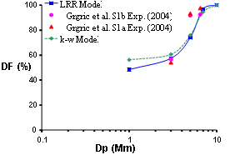

**Figure 2.** Comparison of the present numerical results with the experimental data for deposition fraction of microparticles in a flow rate of 60 lit/min. (size 10)

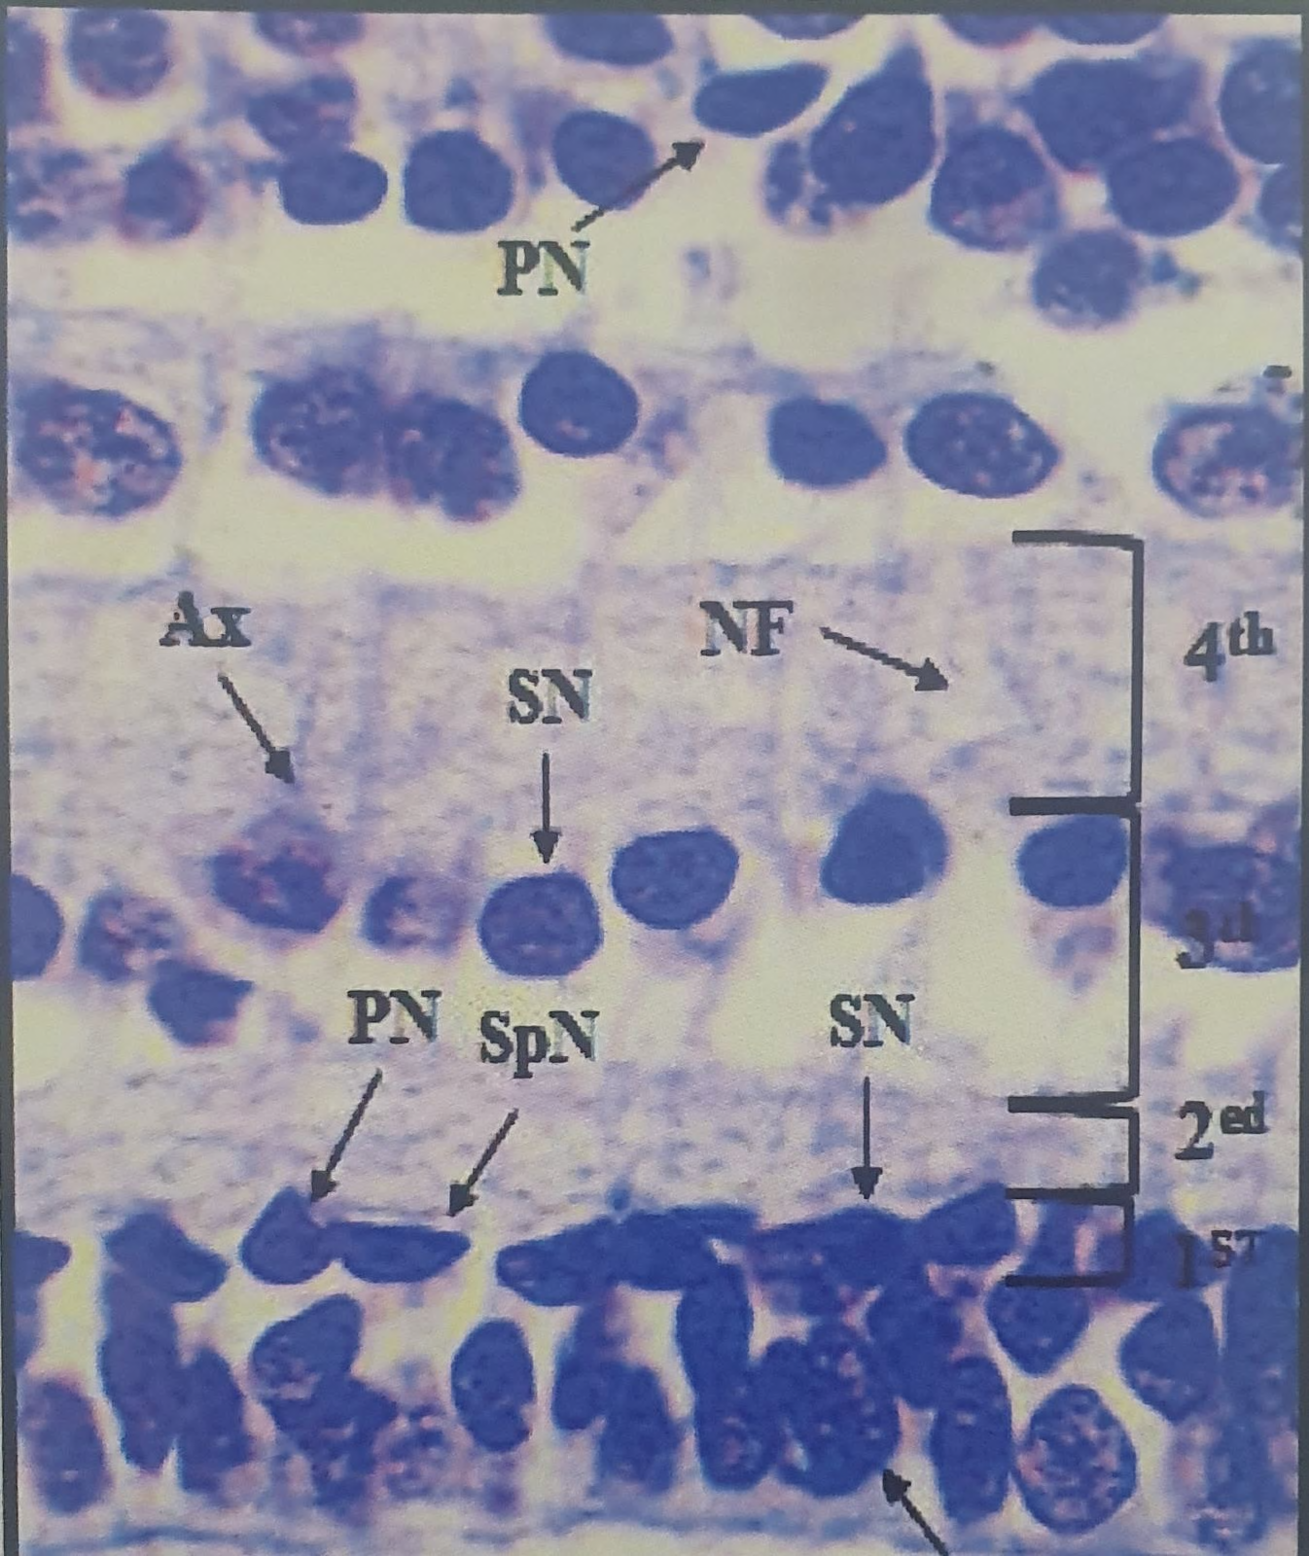

**Figure 3.** Type of section, Name of organ, Scientific name of animal or plant with all details of section, type of stain and magnification power 4x or another powers. (size 10)

Also, your paper's figures must be without background fill color, no border figure and no border legend, no vertical line, no horizontal line, and better quality for publishing.

All Equations have a special number and references in the body same as Equation (1)

$G_{i}=\sqrt{-2\ln{U_{i}}}\text{ cos}(2πU_{j})$ (1)

It is better that write equations with Math Type software or with Equation of office 2010.

During the text, the body writes **Table 1** or **Figure 1,** and in the figure, the caption writes **Figure 1** or **Table 1.**

Please send all pictures in JPEG format figures with the resolution of more than 300 dpi and less than 600 dpi and without borders, with the capital first letter of axis titles and write its unit. Tables and Figures are placed in the results in the sequence mentioned, not at the end of the manuscript.

Also, their subsections must be Capitalized each word, font size in bold 12p. as

**2.1.** **Subsections**

**2.2. Subsections**

**2.2.1. Subsubsection**

**3. Results**

Present your results in logical sequence in the text, tables, and illustrations, giving the main or most important findings first, based on your objective of the study. Do not repeat all the data in the tables or illustrations emphasize or summarize only the most important observations. Extra or supplementary materials and technical detail can be placed in an appendix where they will be accessible but will not interrupt the flow of the text, or they can be published solely in the electronic version of the journal.

When data are summarized, give number and percent in the format of xx(xx%), the absolute numbers from which the derivatives were calculated, and specify the statistical methods used to analyze them, for example, 5(20%) without space between the number and bracket containing percentage (avoid using formats of 46%(460), 46%(460/1000) unless in exceptional cases to better explain the flow of text), no space between number and percentage (e.g., 20%), SD(45±1.12), p<0.05, p>0.05, p=0.05 (use no space before after symbol).

**4. Discussion**

Emphasize and start a discussion with the important finding/s of ‘your study’ and the conclusions that follow from them to support your study objective. Do not repeat in detail data or other information given in the ‘Introduction or the Results section’. Begin by summarizing the main findings, then explore possible mechanisms or explanations for these findings, compare and contrast with relevant literature with a logical explanation as to why your findings are similar or different, state the limitations of the study based on your methodology and findings, and explore the implications for future research/practice. Discussion should be written in ‘triangle’ form ‘starting from your study to the regional and global, opposite to the structure of ‘introduction’.

**Note: The authors can separate or merge the results with the discussion.**

**5. Conclusion**

Should be linked and reflect the objective of the study but avoid unqualified statements not adequately supported by the data. Do not make statements on economic benefits and costs unless the manuscript includes the data and analyses. Avoid claiming priority or alluding to work that has not been completed. State new hypotheses when warranted. Unsubstantiated by data, yet important assumptions are best elaborated in the discussion section

**Acknowledgment**

Acknowledgments are a place to recognize any contributions made to the paper that do not meet the criteria for authorship. This may include technical support, gifts received, or organizational assistance. There are few restrictions on what should be included, with the primary exception that anyone who meets the criteria for authors must be included as an author and not merely acknowledged. Personal acknowledgments (e.g., of family members) are acceptable, and it is recommended to add the full name for them; titles (Dr., Mr., Prof., etc.) should not be used. This section should be kept relatively short.

**Conflict of Interest**

A conflict of interest is any relationship or sphere of interest that may directly or indirectly influence or bias the work. All authors should include a statement disclosing any financial or other substantive conflicts of interest that may be construed to influence the results or interpretation of their manuscript.

If there is no conflict of interest the authors should state that:

“The authors declare that they have no conflicts of interest.”

**Funding**

Financial support in preparation for the publication is included in the funding section**.**

**Ethical Clearance**

Ethics of scientific research were carried out in accordance with the international conditions followed in dealing with laboratory animals, and included animal health, husbandry and care for it, and providing appropriate conditions for it in terms of food, and appropriate methods were adopted in dealing with it when experimenting, and this is consistent with the instructions of the Iraqi Ministry of Health and Environment.

**References**

References should be numbered consecutively in the order with square brackets e.g. [1] for the first reference in the body of articles, the second reference should be [2], etc…… Referencing style is (**Administrative Sciences)**, which is available in Mendeley and Endnote. Please follow the instructions below <https://paperpile.com/s/administrative-sciences-citation-style/>

1. References are written only in the English language
2. References font size must be 11.
3. 50% of references are recent and are within the last 5 years.
4. Conference references should not exceed 20% of the total references number.
5. Find articles published in our journal, related to the topic of your research and cite at least two of them.
6. **Add a DOI link to all articles mentioned in references**, at the end after the pages numbers (if the article has no Doi, please add the article’s URL)
7. References to papers accepted but not published should be designated as “in the press” or “forthcoming”; authors should obtain written permission to cite such papers as well as verification that they have been accepted for publication. State the journal name and, if possible, the year and volume.

The information below shows the citation process (**Administrative Sciences**): -

Journal article

Author 1, A.B.; Author 2, C.D. Title of the article. *Abbreviated Journal Name* **Year**, *Volume*, page range. http//:doioooooooooooooo

Ex:

1. McKinney, J.D. Technology: Photonics Illuminates the Future of Radar. *Nature* **2014**, *507*, 310–311. <https://doi.org/10.1038/507310a>
2. Li, X.; Xu, J. Dietary and Circulating Lycopene and Stroke Risk: A Meta-Analysis of Prospective Studies. *Sci. Rep.* **2014**, *4*, 5031. <https://doi.org/10.1038/srep05031>
3. Spencer, T.J.; Osborn, T.; Kohl, P.A. Materials Science. High-Frequency Chip Connections . *Science* **2008**, *320(2)*, 756–757. <https://doi.org/10.1038/srep05031>
4. Wang, Y.-Q.; Jiang, R.; Kolomeisky, A.B.; Hu, M.-B. Bulk Induced Phase Transition in Driven Diffusive Systems. *Sci. Rep.* **2014**, *4(1)*, 5459. <https://doi.org/10.1038/srep05031>

**Books and book chapters**

Here are examples of references for authored and edited books as well as book chapters.

An authored book

Stocker, A.A. *Analog VLSI Circuits for the Perception of Visual Motion*; John Wiley & Sons, Ltd: Chichester, UK, 2006; ISBN 9780470034897.

An edited book

Härdle, W.K. *Applied Multivariate Statistical Analysis*; Simar, L., Ed.; 3rd ed. 2012.; Springer: Berlin, Heidelberg, 2012; ISBN 9783642172281.

A chapter in an edited book

Hadjiona, M.; Georgiou, C.; Papa, M.; Vassiliou, V. A Hybrid Fault-Tolerant Algorithm for MPLS Networks. In *Wired/Wireless Internet Communications: 6th International Conference, WWIC 2008 Tampere, Finland, May 28-30, 2008 Proceedings*; Harju, J., Heijenk, G., Langendörfer, P., Siris, V.A., Eds.; Lecture Notes in Computer Science; Springer: Berlin, Heidelberg, 2008; pp. 41–52 ISBN 9783540688051.

**Websites**

Sometimes references to websites should appear directly in the text rather than in the bibliography. Refer to the Instructions to authors for [Administrative Sciences](http://www.mdpi.com/authors/references).

Blog post

Davis, J. Source Of Antarctica’s Mysterious “Blood Falls” Discovered Available online: https://www.iflscience.com/environment/source-antarcticas-blood-falls-discovered/ (accessed on 30 October 2018).

**Thesis and dissertations**

Thesis including Ph.D. dissertations, Master's theses, or Bachelor theses follow the basic format outlined below.

Doctoral dissertation

Zhou, Y. Resource Management in Wireless Networks: Queue Management and Scheduling in Mesh Networks and Multi-Access Control in Internetworking Systems. Doctoral dissertation, George Washington University: Washington, DC, 2010.