Title (Must be Written in Times New Roman with Fonts 14 p)

Author name^{1*}, Author name², and Author name³ 12pt
¹Department, College, University, City, Country.
²Department, College, University, City, Country.
³Department, College, University, City, Country.
*Corresponding Author. 10pt
Beginning with Volume 40, the journal will transition to this updated template.

Received: dd/mm/yyyy. Revised: dd/mm/yyyy. Accepted: dd/mm/yyyy. Published: dd/mm/yyyy.
doi.org/00.000000.000000
© 2026. The Author(s). Published by College of Education for Pure Science (Ibn Al-Haitham), University of Baghdad. This is an open-access article distributed under the terms of the Creative Commons Attribution 4.0 International License

Abstract 10pt
Use Microsoft Word 2016 or later when you are writing your manuscript. The manuscript must be formatted for the IHJPAS journal. Each word in the manuscript titles should start with a capital letter, avoiding long formats that include underscores. Short formulas identifying the elements are acceptable (e.g., "Nd–Fe–B"). The abstract must be structured as background, objectives, materials and methods, results, conclusion, and should contain between 150 and 300 words.
Keywords: (4-6 words). It should be written in Times New Roman, single-spaced, with line spacing of 1 and 10p font size, and acronyms should be avoided. To help you create keywords from an abstract, use MeSH on Demand (https://meshb.nlm.nih.gov/MeSHonDemand) as a tool that can automatically generate keywords.

- Introduction (12pt)
Provide a background for the study and the nature of the problem. State the specific purpose, the research objective, the state of knowledge, and the research gap. Do not include introductory tables or figures. Include only directly relevant references. The Introduction must not exceed 1000 words.

- Materials and Methods or its equivalents in mathematics and computer science research (12pt)
Include details on materials and methods by describing the processes and procedures, if the methods are new or substantially.
If there is a need to add any subsection within the “Materials and Methods,” “Results,” or “Discussion” sections, it must be written as follows:
2.1. Subsections
Should start at the beginning of the line without any indentation.
2.1.1. Sub-Subsections
2.1.2. Sub-Subsections
- Results or its equivalents in mathematics and computer science research (12pt)
Present your results logically in the text, tables, and figures. First, give the main or most important findings based on your study objective. Do not repeat all the data in the tables or figures. Emphasize or summarize only the most important observations.
Tables: The caption font size is 10pt
The title of the table should be written at the top, with the text aligned within the cells. Use the symbol (*) for footnotes.

Table 1. The number for different geometric cases (size 10p)
HD | VD = 0 | VD = 1
3 | 0.198 | 0.083
5 | 0.184 | 0.1
7 | 0.176 | 0.2

Figures
The caption of the figure should be below it. It must be in TIFF format with a resolution of at least 600 dpi to ensure clarity and high quality. Figures must not contain any logos or watermarks. For multi-panel figures, use small letters (a, b, c, …) as labels, positioned centered below each panel.

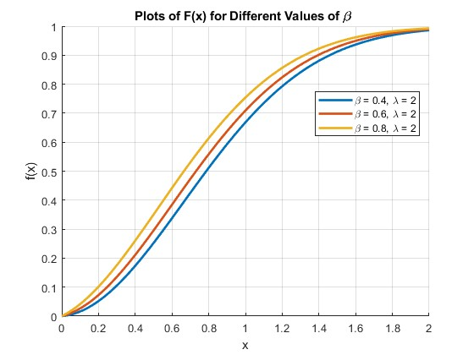
Figure 1. The shape of cdf for new Shanker Weibull distribution with different values of $β$(size 10p)

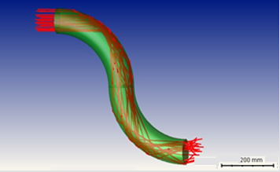
a
Figure 2. S-shape circular cross-section torus waveguide model (size 10p)

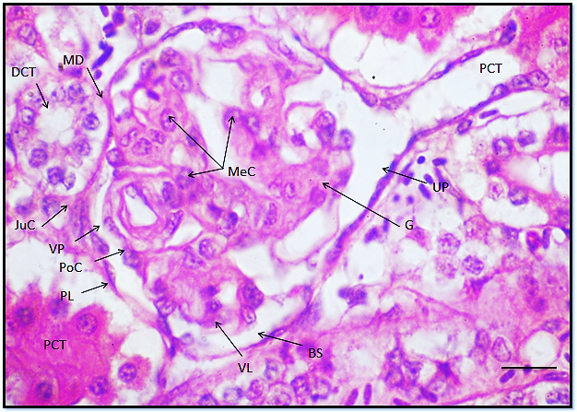

Figure 3. Type of section, Name of organ, Scientific name of animal or plant with all details of section, type of stain and magnification power 4x or another power, scale bar. (size 10)

Equations
To ensure accuracy and professional formatting, all equations must be written using the equation editor in Microsoft Word.
$G_{i}=\sqrt{-2\ln{U_{i}}}\text{ cos}(2πU_{j})$ (1)

Note: When referring to a figure, table, and equation within the text, its number must be clearly stated and in bold, such as "according to Figure 1, Table 1, Scheme 1 and Equation (1), respectively.

- Discussion or its equivalents in mathematics and computer science research (12pt)
In this section, highlight the key findings of your research, and initiate a discussion to support your study objective. Do not repeat the data or other information from the ‘Introduction or Results' section in detail. Begin with a summary of the main findings, then explore possible mechanisms or explanatory limitations for these findings. Do not refer to the tables or figures in the Discussion section.
Note: The results and Discussion sections must be separated in the Biology, Chemistry, and Physics manuscripts, while they can be merged in the Computer and Mathematics manuscripts.

- Conclusion (12pt)
It must include the concluded results in a concise paragraph of 150–250 words.

Acknowledgment (12pt)
Acknowledgments are a place to recognize any contributions made to the manuscript that do not meet the criteria for authorship. This may include technical support or organizational assistance.

Conflict of Interest (12pt)
All authors should include a statement disclosing any financial or other substantive conflicts of interest that may be construed to influence the results or interpretation of their manuscript.
If there is no conflict of interest, the authors should state that: “The authors declare that they have no conflicts of interest.”

Funding (12pt)
The funding section must include any financial support for the submitted work.

Ethical Clearance (12pt)
Ethical approval obtained should be mentioned (number and date). Indicate whether the procedures followed were according to ethical standard. When reporting experimental results, indicate whether the institution’s or a national research council’s guidelines or national laws were followed.

Author Contributions (12pt)
All authors contributed to the conception and design of the study. The authors participated in data collection, analysis and interpretation of the results, critically reviewed the manuscript, and approved the final version for publication. All authors agree to be accountable for all aspects of the work and ensure the accuracy and integrity of the study.

Artificial Intelligence Statement (12pt)
During the preparation of this manuscript, the authors did not use AI to fabricate results, invent or alter underlying data, or generate figures that are not faithfully derived from the underlying data and methods used in the research.
Or
During the preparation of this manuscript, I/we used [NAME OF TOOL / SERVICE] in order to [REASON]. After using this tool/service, I/we reviewed and edited the content as needed and I/we take full responsibility for its content.

References
References should be cited in the text (Introduction, Materials and Methods and Discussion) with consecutive numbers (superscript) as following:
- If the sentence cites two references^{1, 2}
- If the sentence cites four references^{1– 4}
- The cites of non-sequential references^{1– 4, 7– 9, 11}
The references must be in Vancouver format (11pt).
Mendeley reference manager is preferred to be used to organize the reference list with DOI. The font size of the references must be 11pt. The references must be (70%) the last seven years. At least 20% of the manuscript’s references must be from journals, books, etc. that are indexed in the Scopus database.

Examples:
The information you provide differs according to the type of source you’re citing since different details are relevant in various cases. Formats and examples for the most commonly cited source types are given below.
Book
Format | Author(s). Title. Edition. Place of publication: Publisher; Year.
For Single Author | Hoppert M. Microscopic techniques in biotechnology. Weinheim (Germany): Wiley-VCH; 2003.
E-book: Two or More Authors or Editors | Murray PR, Rosenthal KS, Kobayashi GS, Pfaller MA. Medical microbiology. 4th ed. St. Louis: Mosby; 2002.
Book: Two or More Authors or Editors | Gilstrap LC, Cunningham FG, Van Dorsten JP, editors. Operative obstetrics. 2nd ed. New York: McGraw-Hill; 2002.

Book chapter
Format | Author(s). Title of chapter. In: Editor(s), editors. Title of book. Place of publication: Publisher; Year. Page range.
Chapter or Article in Edited E-book | Jones NA, Gagnon CM. The neurophysiology of empathy. In: Farrow TFD, Woodruff PWR, editors. Empathy in mental illness [e-book]. Cambridge (UK): Cambridge University Press; 2007: 217-38. https://ebookcentral-proquest-com.libproxy.murdoch.edu.au/lib/murdoch/detail.action?docID=293348.
Chapter or Article in Edited Print Book | Meltzer PS, Kallioniemi A, Trent JM. Chromosome alterations in human solid tumors. In: Vogelstein B, Kinzler KW, editors. The genetic basis of human cancer. New York: McGraw-Hill; 2002. p. 93-113.

Journal article
Format | Author(s). Article title. Journal Name. Year; Volume(Issue):page rang. DOI
Example | Abalos E, Carroli G, Mackey ME. The tools and techniques of evidence-based medicine. Best Pract Res Clin Obstet Gynaecol. 2005;19(1):15-26. https://doi.org/10.1016/j.bpogyn.2004.10.008

Thesis and dissertations

 | Thesis including Ph.D. dissertations, Master's theses, or Bachelor theses follow the basic format outlined below.
Example | Zhou Y. Resource Management in Wireless Networks: Queue Management and Scheduling in Mesh Networks and Multi-Access Control in Internetworking Systems. Doctoral dissertation, George Washington University: Washington, DC, 2010.

Datasets:

Example | Coin L. Genomics of development and disease [dataset]. 2014 Jun 1. The University of Queensland. Available from: http://dx.doi.org/10.14264/uql.2016.583

Conference Manuscripts

Example | Khalifa ME, Elmessiry HM, ElBahnasy KM, Ramadan HMM. Medical image registration using mutual information similarity measure. In: Lim CT, Goh JCH, editors. Icbme2008: Proceedings of the 13th International Conference on Biomedical Engineering; 2008 Dec 3-6; Singapore. Dordrecht: Springer; 2009. p. 151-5.

